Comprehensive Lab Guide for UNIX Operating System

Course ID： | 611086 | Category： | Major Elective | Hours： | 2

- Objectives
On Windows, connect to a UNIX/Linux server via SSH, install and configure a web server, then deploy a blog website.
- Contents
  - Configure network parameters to establish network connection between Windows and UNIX/Linux system.
  - Use an SSH client to connect to UNIX/Linux from Windows, then install and configure a web server.
  - Deploy and test a blog website on UNIX/Linux system.
  - On Windows, use the hosts file as domain name service, map a domain name to IP address, and then access the blog website using the domain name.
- Equipment for Every Group (two students per group)
  - Hardware: 2 PCs or VMs, 1 network switcher or virtual network switcher, 2 Cat5 network wires or without any network wire (virtual)
  - Software: Windows 10/11，VMware workstation 15/16, Ubuntu 20 LTS, MobaXterm.
- Network Topolog



192.168.n.x
192.168.n.y


Windows 10/11
MobXterm
Ubuntu 20 LTS
on VMware workstation 15/16

notes：the values of n, x and y in the IP address are:
- The n is 1, 2, 3, 4 accordingly for students from class 1, 2, 3, 4
- The x is the last two digits of Student ID of one of the two students of the group, the y is the same for another student.
- If the group has only one student, thus the student need to use 2 IP addresses, the x is the last two digits of the Student ID, the y is the last two digits of the student ID plus 100
- e. g. the last two digits of one student ID is 05, if the student is from class 1, should use the IP address 192.168.1.5, if from class 2 should use the IP address 192.168.2.5, if need another IP address, should use the second IP address 192.168.1.105 from class1, 192.168.1.205 from class 2.
- The n value in two IP address in the same group should be the same, otherwise the two machines can’t make communication over network.
- Solutions
On-site lab in the laboratory that locating in the main building of our college. There are two students in every group, the group should accomplish the lab independently.
- The steps of theLab
  - Configure network parameters to establish network connection between Windows and UNIX/Linux system.
    - On the desktop of the Windows machine, right-click "Network" icon, and select "Properties" from the pop-up menu. In the left pane of the pop-up window, choose "Change adapter settings". In the new window, right-click the "Ethernet" icon and select "Properties" from the popup menu. Double-click Internet Protocol Version 4 ( TCP/IPv4 )" in the pop-up window. Configure the machine's IP address as 192.168.n.x, subnet mask as 255.255.255.0, and leave both gateway and DNS blank. (Note: Here, n and x should be replaced by numbers assigned to the Windows machine's IP address in the previous section)
    - If there is a firewall on this Windows machine, turn it off.
    - Launch VMware Workstation on another Windows machine and select the virtual machine "ubuntu-20.04.3-desktop". From the VMware Workstation menu bar, click "Virtual Machine (M)" menu and choose the "Settings (S)..." menu item. In the left list box of the pop-up window, select "Network Adapter". In the "Device Status" section on the right, check "Connect at power on". In the "Network Connection" section, select "Bridged Mode(B)", check "Replicate physical network connection state (P)", and click the "OK" button.
    - Start the ubuntu-20.04.3-desktop virtual machine and login using Student account. If login via X Window, launch the Terminal program within X Window.
    - In the Terminal, use the command “sudo vi /etc/netplan/01-network-manager-all.yaml” to modify the configuration file. Set the machine's IP address to 192.168.n.x and subnet mask to 255.255.255.0. The content of the configuration file is as follows. Note that indentation in the file must use spaces (two spaces per indent) instead of tabs. After modifying and saving the configuration file, execute “sudo netplan apply” to make the new settings take effect.
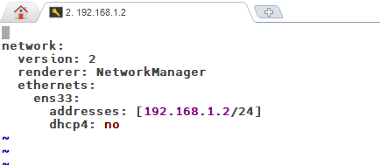
    - Use the command “ip addr” to verify whether the IP address has been set correctly.
    - Use the command “sudo systemctl stop ufw ” to turn of the firewall on Ubuntu:
On both Ubuntu and Windows machines, use the ping command to test mutual connection. On Ubuntu, use “ping 192.168.n.x” command to test the network connection with Windows. On Windows, use “ping 192.168.n.y” to test network connection with Unbuntu.
  - Use an SSH client to connect to UNIX/Linux from Windows, then install and configure a web server.
    - On another Windows machine, launch the MobaXterm software. Click the "Session" icon on the toolbar. In the pop-up window, select the "SSH" icon. Enter the IP address of the Ubuntu virtual machine in the "Remote host *" field and click the "Ok" button. Select "Accept" when prompted.
    - At the "login as:" prompt in the resulting window, enter the Ubuntu username "student" and password "student" to log in. If the dialog box "Do you want to save password…" appears, select "No".
    - Execute the command “sudo apt install nginx”, and follow the prompts to install the Nginx web server software. If Nginx is already installed on the system, the message "nginx is already the newest version" will appear.
    - Open a web browser, enter the Ubuntu IP address in the address bar to access the newly installed Nginx homepage. If the webpage displays a message that contains the text "Welcome to nginx!", the installation is successful.
  - Deploy and test a blog website on UNIX/Linux system.
    - In the MobaXterm window where you’ve logged into Ubuntu via SSH, execute the command “sudo apt install sqlite3”, and follow the prompts to install the SQLite3 database. If SQLite3 is already installed on the system, the message "sqlite3 is already the newest version" will appear.
    - Execute the command “sudo apt install php-fpm php-curl php-gd php-mbstring php-xml php-sqlite3”, and follow the prompts to install the PHP software. If the PHP components are already installed, the following messages will appear: "php-fpm is already the newest version", "php-curl is already the newest version", "php-gd is already the newest version", "php-mbstring is already the newest version", "php-xml is already the newest version", and "php-sqlite3 is already the newest version".
    - Open a File Explorer window. Locate the extracted folder “typecho” of the open-source blog software Typecho (stored in C:\UnixLab), then drag and drop it into the student home directory (/home/student) in the left pane (SSH browser) of MobaXterm. MobaXterm will start uploading the folder to the Ubuntu server.
    - In MobaXterm, execute the command “sudo cp -r /home/student/typecho /var/www” to copy the “typecho” folder to the web sites directory “/var/www”.
    - Continue by executing the command “sudo chmod -R 777 /var/www/typecho” to set the permissions of the typecho directory to allow read, write, and execute for all users.
    - Execute the command “cp /etc/nginx/sites-enabled/default ./default.nginx.bak” to back up the Nginx original configuration file to the current directory (home directory). This allows restoration of the original settings if errors occur during subsequent modifications.
    - Execute the command “sudo vi /etc/nginx/sites-enabled/default” to modify the Nginx configuration file and set the parameters for the Typecho blog website. The content to be modified or added is shown in the red box in the figure below.
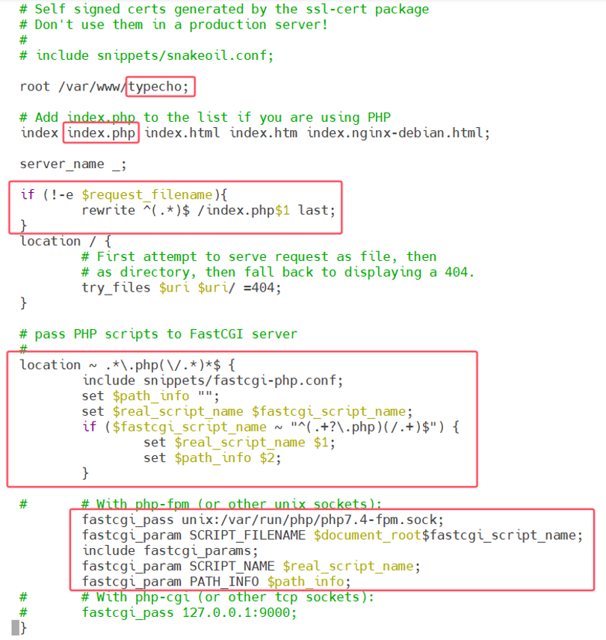

    - Then execute the command “sudo systemctl restart nginx”, to restart the Nginx service to make the the modified configuration take effect.
    - Open a web browser, enter the Ubuntu IP address in the address bar to access the newly configured Typecho blog website. Follow the prompts to configure the website parameters and test all functions of the website.
  - On Windows, use the hosts file as domain name service, map a domain name to IP address, and then access the blog website using the domain name.
    - On the Windows machine, locate the file "C:\Windows\System32\drivers\etc\hosts" and uncheck the "Read-only" attribute in its properties.
    - Right-click the Notepad3 icon on the desktop, select "Run as administrator" from the pop-up menu. In Notepad3, open the "hosts" file located in the directory "C:\Windows\System32\drivers\etc", add the following line at the end of the file, and save it.
192.168.n.y www.myblog.com
    - On Windows, open a new “cmd” window and run the command “ping www.myblog.com”. It will resolve the domain name “www.myblog.com” to the IP address 192.168.n.y.
    - Open a web browser, enter "www.myblog.com" in the address bar, and you will be able to access the blog website.
- The Requirements of the Lab
Complete this experiment in accordance with the aforementioned experimental procedures, record the experimental process, data and results in detail, and write an experimental report.
Note: In the experimental report, replace the data in this instruction manual with your own actual experimental data.

College of Mathematics and Informatics of South China Agricultural University
November 2026

